ITI – Bash Scripting Lab 2
Mohammad Tarek – Data Management

- Create a script that asks for user name then send a greeting to him.
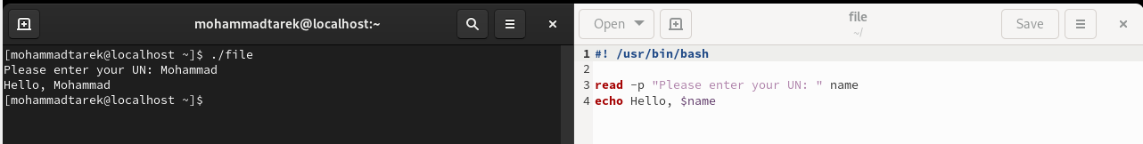
- Create a script called s1 that calls another script s2 where: a. In s1 there is a variable called x, it's value 5 b. Try to print the value of x in s2 by two different ways.
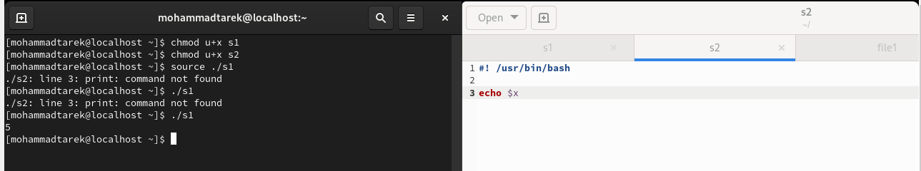
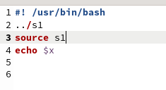
- Create a script called mycp where: a. It copies a file to another b. It copies multiple files to a directory.
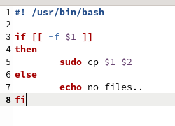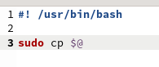
- Create a script called mycd where: a. It changed directory to the user home directory, if it is called without arguments. b. Otherwise, it change directory to the given directory.
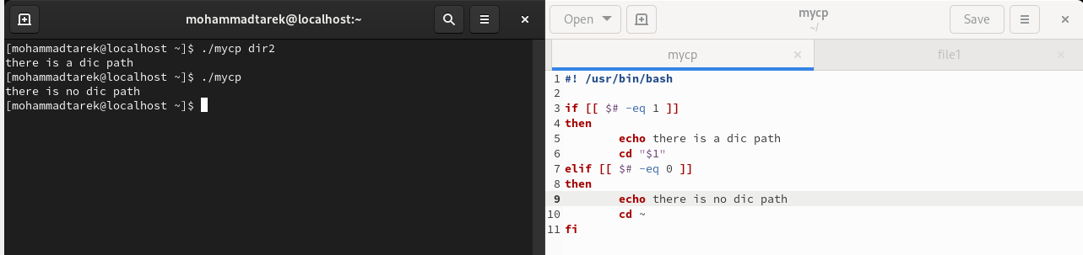
- Create a script called myls where: a. It lists the current directory, if it is called without arguments. b. Otherwise, it lists the given directory.
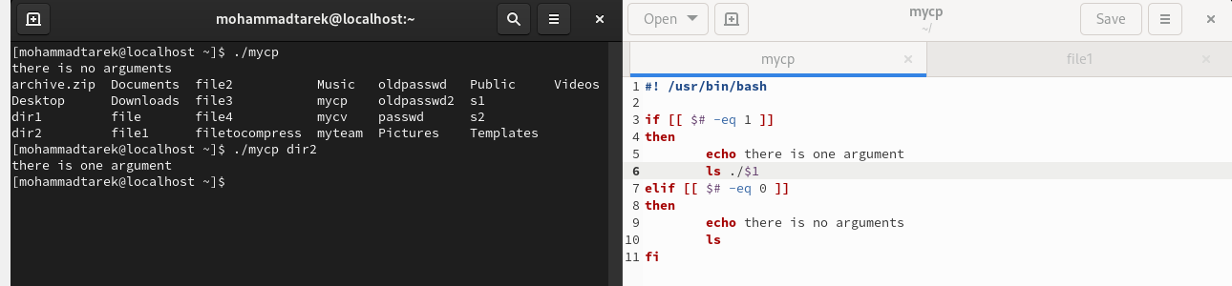
- Enhance the above script to support the following options individually: a. –l: list in long format b. –a: list all entries including the hiding files. c. –d: if an argument is a directory, list only its name d. –i: print inode number e. –R: recursively list subdirectories
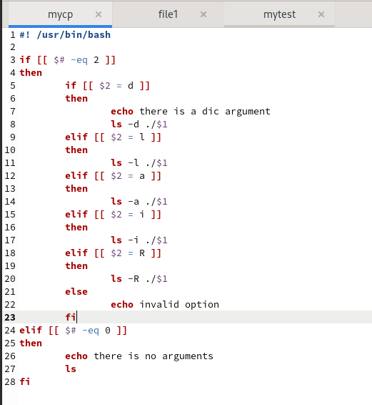
7)
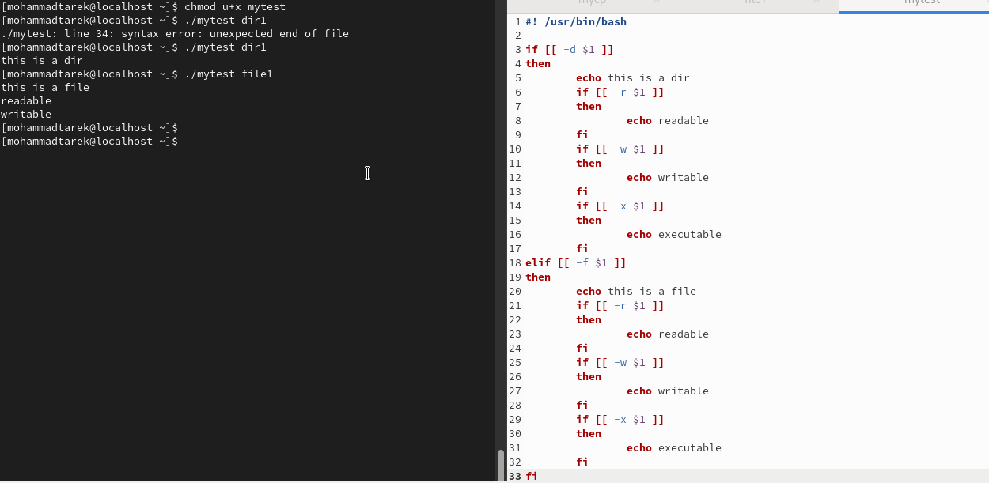
8)
